Car Rental System



Submitted by:
- Khadija_tul_Kubra (NUM-BSCS-2024-30)
- Farwa Imran (NUM-BSCS-2024-22)

CSC-241 Computer Organization and Assembly Language

Department of Computer, Namal University Mianwali

1. Introduction
Computer Organization and Assembly Language is a core subject that helps students understand how software interacts directly with hardware. Unlike high-level languages, assembly language provides low-level control over system resources such as registers, memory, and input/output operations. This project, titled "Car Rental System" is developed to practically demonstrate these concepts in a real-world scenario.
The purpose of this project is to design and implement a menu-driven car rental management system using MASM32 assembly language. The system allows users to rent cars, return rented cars, view available cars, and view currently rented cars through a console-based interface. This project highlights how complex logical operations, data handling, and user interaction can be managed using assembly language.
The scope of this project includes the use of Windows API functions, memory management through arrays, procedure-based modular programming, and arithmetic operations for rent calculation. It is highly relevant in understanding the internal working of computer systems and strengthening problem-solving skills at the hardware–software interface.

2. Problem Statement

Manual car rental management systems can be inefficient, error-prone, and difficult to manage, especially when tracking car availability, rental quantities, and cost calculations. High-level programming languages simplify these tasks, but they hide the underlying hardware operations.
The problem addressed by this project is to develop a fully functional car rental system using assembly language, which handles:
- Car availability tracking
- Rental and return operations
- Input validation
- Cost calculation based on quantity and rental days

The challenge lies in implementing these features using assembly language, which does not provide built-in data structures, loops, or input/output handling mechanisms like high-level languages. Therefore, the system must rely on low-level instructions, registers, memory addressing, and explicit control flow.

3. Proposed Solution
To solve the stated problem, a console-based Car Rental System is implemented using MASM32. The solution follows a modular approach where each major functionality is implemented as a separate procedure. Parallel arrays are used to store car names, total quantities, rented quantities, and rental rates.
The program uses Windows API functions such as StdOut, StdIn, and ExitProcess for user interaction. Input validation ensures that users enter values within valid ranges. Arithmetic operations are performed manually to calculate rental costs.
Key computer organization and assembly concepts used include:
- Register-based operations (EAX, EBX, ECX, EDX)
- Memory addressing and indexing
- Procedure calls and stack management
- Conditional branching and loops
- ASCII to integer and integer to ASCII conversions

3.1 Flow Diagram
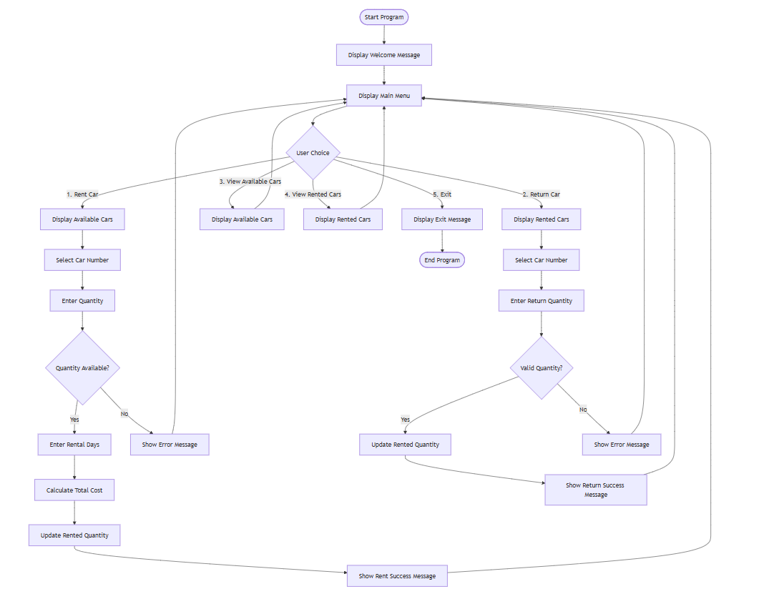
Fig: Flow Diagram of Car Rental System

3.2 Pseudo Code
Display Welcome Message
LOOP
Display Menu
Read User Choice

IF choice == 1 THEN
Display Available Cars
Select Car
Enter Quantity and Days
IF quantity available THEN
Update rented quantity
Calculate total cost
Display success message
ELSE
Display error message
ENDIF

ELSE IF choice == 2 THEN
Display Rented Cars
Select Car
Enter Return Quantity
Update rented quantity
Display success message

ELSE IF choice == 3 THEN
Display Available Cars

ELSE IF choice == 4 THEN
Display Rented Cars

ELSE IF choice == 5 THEN
Exit Program
ELSE
Display Invalid Choice
ENDIF
END LOOP
END

3.3 Assembly Code
The Car Rental System is developed using MASM32 assembly language and follows a procedure-based programming approach. The program uses Windows API functions such as StdOut, StdIn, and ExitProcess to handle user input, output, and program termination.
All car-related data, including car names, total quantities, rented quantities, and rental rates, are stored in the .data section using parallel arrays. Each car is accessed using the same index across all arrays, which simplifies data management in assembly language.
The assembly code of the Car Rental System is organized into multiple procedures, where each procedure performs a specific task to ensure modularity and clarity.
- num_to_str
This procedure converts numeric values into string format so that numbers can be displayed using output functions.
- get_car_name
It returns the memory address of a car name based on the selected car index.
- display_car
This procedure displays complete information of a single car, including name, rental rate, available quantity, and rented quantity.
- display_available_cars
It lists only those cars whose available quantity is greater than zero.
- display_rented_cars
This procedure displays cars that are currently rented by checking rented quantities.
- display_returnable_cars
It shows cars that are eligible to be returned (cars with rented quantity greater than zero).
- get_number
This procedure takes numeric input from the user and validates it within a specified range.
- rent_car_function
It handles the car renting process, including car selection, quantity input, rental days, cost calculation, and updating rented quantities.
- return_car_function
This procedure manages the return of rented cars and updates the rented quantity accordingly.
- view_available_function
It calls the procedure to display all available cars.
- view_rented_function
This procedure displays all currently rented cars.
- start / main_menu
This is the main control section of the program that displays the menu, processes user choices, and controls program flow.

4. Results and Findings
The Car Rental System was successfully implemented and tested in the MASM32 environment. The program correctly displays menus, processes user input, updates car availability, and calculates rental costs.
Key observations include:
- The system accurately tracks available and rented cars.
- Input validation prevents invalid or out-of-range values.
- Modular procedures improve code readability and reusability.
- The program demonstrates efficient use of registers and memory.
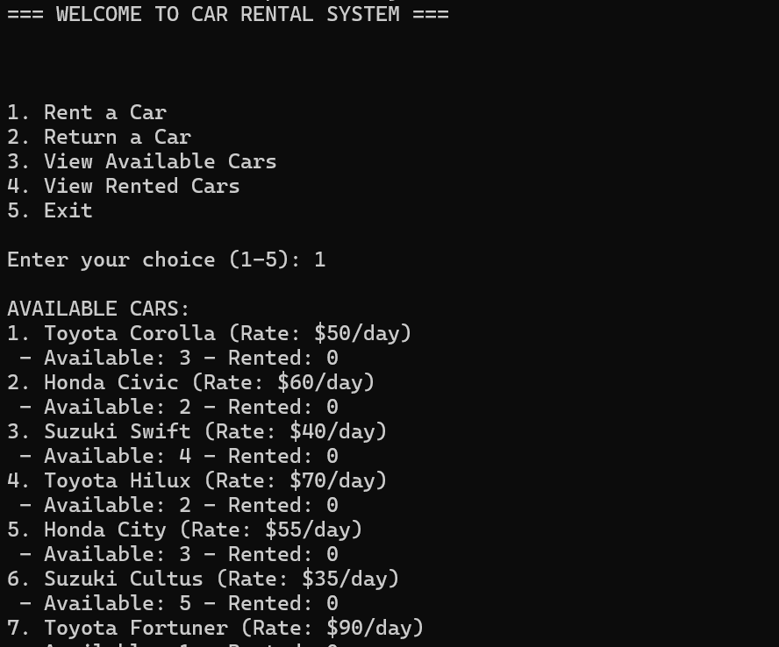

5. Conclusion
This project successfully demonstrates the implementation of a real-world application using MASM32 assembly language. The Car Rental System effectively addresses the problem of managing car rentals by providing a structured, menu-driven interface with proper validation and cost calculation.
Despite the limitations of assembly language, such as lack of high-level abstractions, the project highlights how complex systems can still be developed using low-level programming techniques. The project enhanced understanding of computer organization, memory management, and instruction-level execution.
Future improvements may include file handling for data persistence, graphical user interface integration, and dynamic data structures for scalability.

Additional Sections
- References:
- Kip Irvine, Assembly Language for x86 Processors
- MASM32 Documentation
- Microsoft Windows API Documentation
- Mermaid Chart (for Flowchart)
- Appendices:
- Complete Assembly Code
- Sample Program Output

